Mobile Applications Development Report

SET08114

40116512 - Liam Aitken

1 - Introduction

The mobile application I have chosen to develop is called Guaca-Mole. This is a small and short mobile game based and adapted from the popular arcade game Whacka-Mole. The game tests the user’s reaction speed, by having them attempt to smash cartoon avocados before they can disappear again, increasing the users score by 10 points with every successful smash. Each game last 30 seconds, during which cartoon avocados appear and disappear as the user tries to “smash” by tapping them on the screen.
As the idea is based on Whacka-Mole, the name Guaca-Mole is a play on words since avocados are used to make the Mexican dipping sauce Guacamole, and also that it rhymes with “Whacka-Mole”.
The inspiration for a Whacka-Mole based idea came from my childhood visits to many game arcades. I have played the game “Whacka-Mole” many, many times and it is one that has always stuck in my head as being something that is so simple, yet so popular. The inspiration for using the avocados as the in-game characters came from my Mother, who suggested putting an unorthodox twist on an already classic game.

2 - Software Design

The basic design behind the app was to have 3 activities. The first of these was to display a short splash screen displaying the app logo, which would be timed to disappear after a short while. Following this, the game activity would start, allowing the user to play for 30 seconds. Upon the completion of this 30 second game, the activity to display the time message up message and the user’s score. There would also be a button on this page to allow the user to play again.

Time Up!
Score: 0
Time: 30
You Scored: 270!

Splash Screen
Game
Display Score

- Diagram showing basic flow through the application

3 – Implementation

The app is made up of 3 activities as mention in the previous section:
1 – Splash Screen
The splash screen is a simple activity consisting of just an ImageView as the root layout. It displays the app logo, before disappearing after 2 seconds. The timing was handled by an android Handler, which delays the start of the next activity by 2 seconds.

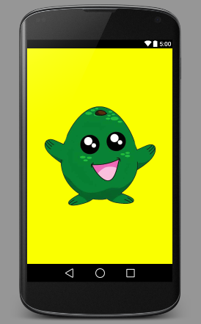

- Screenshot showing the splash screen

2 – Game
The game activity is where the actual game takes place. This activity consists of a TableView as the root layout. There are 9 separate avocado characters contained in this view, all of which are hidden at the start of play. These 9 characters are simply ImageButtons, aligned in a 3x3 grid. TableRow layouts were used to achieve this.
The 30 second game timer is controlled by an android countdown timer, which provides very useful methods for controlling what happens with each tick of the timer, and what happens when the timer finishes etc. This made the logic of the game simple to implement. A random number between 0 and 8 was generated on each tick of the timer, and this number was used to select one of the 9 ImageButtons at random. This chosen ImageButton is then displayed for 2 seconds (the 2 second timer on this is also handled by an android countdown timer). If the user presses the visible button in time, the on click function is called which increases the user’s score by 10 points, and immediately hides the pressed ImageButton. When the time runs out, the timer’s onFinish method is called which launches the next activity, and passes over the users score.

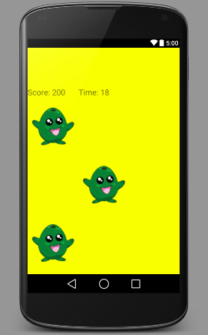

- Screenshot showing the game at a random point of play

3 – Score activity
This simple activity is used to display the time up message and the user’s score. It also contains a button that the user can press to play the game again. The score is passed from the game activity by the Intent’s putExtra() method.

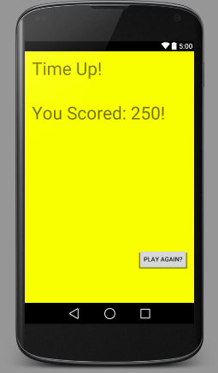
- Screenshot showing the score page

4 – Evaluation

Since this app was able to utilise simple layouts and logic, it was relatively easy to stick to the original design plan. Each activity is laid out according to the original specification and the use of the android timers allows a simple way in which the users reactions to be tested.
Although somewhat a removed attempt from the classic Whacka-Mole games, the core idea behind the game still remains. The app itself was tested on a few people in the class, all of which said they enjoyed playing the game, however, after multiple plays, it was perhaps a little easy to see a few patterns emerging in gameplay, despite the apparent randomness of it.
The game becoming a little predictable is one big possible improvement to this application. With further development, it would be possible to further randomise which button appears, and also to have more than one button appearing at one time. It would also be possible to improve the game by decreasing the time the user has to press the button as the score increases.
Furthermore, I feel the game would have benefited from a pause function of some description.

5 – References and Resource List

Resources used:
Android Studio
http://developer.android.com/tools/studio/index.html
GIMP
http://www.gimp.org/
Cartoon Avocado – Found through Google Images
http://static.ipaustralia.com.au/store3/15/38/1538391.1.high.jpg
References:
Code for Android handlers and Countdown Timers was derived from questions and subsequent answers found on Stack Overflow, and from API guides on the Android developer website.
Android Timer -
http://stackoverflow.com/questions/10032003/how-to-make-a-countdown-timer-in-android
Android Handler –
http://developer.android.com/reference/android/os/Handler.html

